Core allows users to configure system events by specifying what occurrence or action will “trigger” an event and what action or output the event should produce.

There are many different Event Categories, and within each Category, there are many different Event Types.

This guide covers the category of Training Events, and takes you through the following processes:

Creating a new event 1
Editing an existing event 4
Deactivating an existing event 5

Creating a new event

Navigate to: CoreHR > Event Management > Hr Event Configuration

- Open CoreHR and in the toolbar, go to CoreHR > Event Management > Hr Event Configuration
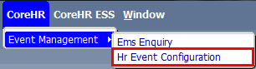
- Select “Training – Employee Courses” from the drop-down menu. All the available Training event types will now appear on the screen.
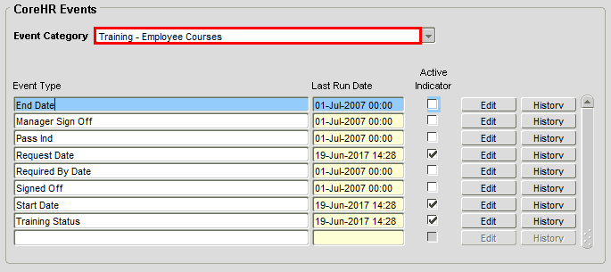

- The Active Indicator flag shows there are three active event types: “Request Date”, “Start Date”, and “Training Status”. Select the event type for which you want to create a new event, and click “Edit”.
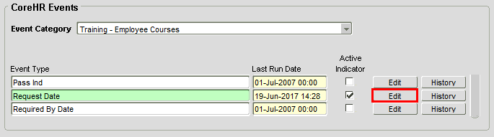

- A pop-up window will open. In the lower half of the window, you can see every event attached to the event type you selected. To view an existing event, select it and click “Edit”. To add a new event, click “Add New Notification”:
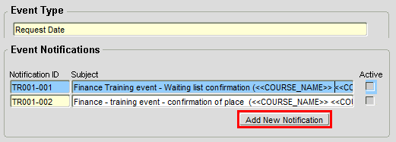
- Select the “Notification Type” that the event should trigger.

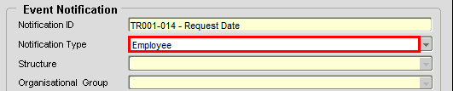

Choose from the following options:

Field Name | Description
Email | Sends event notification to a specified email address
Employee | Sends event notification to all employees registered for a training course
Organisation Role | Sends event notification to employees who hold a specific role, e.g. “Pay Approver”
Person | Sends event notification to a specified Personnel Number
Process | Not in use
Reports to Manager | Not in use
Username | Not in use

- Tell the system how many days Before or After the event to generate the notification:

- Set the Conditions which will trigger this event (these should have been provided by the person who requested the new event).
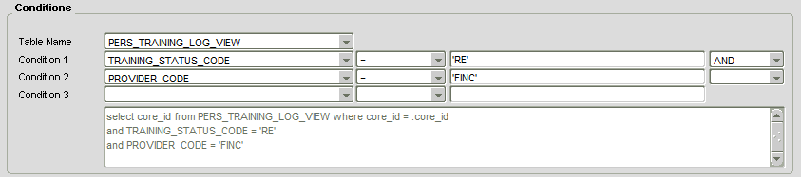

 | Note: If your event is triggered by a PROVIDER_CODE, be sure to check that the code has been set up by navigating to CorePersonnel > Training > Training Maintenance > Course Providers. The PROVIDER_CODE should appear on the screen.  If the PROVIDER_CODE you need isn’t present, you will need to create it by clicking “Add New” and following the on-screen instructions.

- After setting your Conditions, click 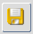 to save your changes. You must do this before you can configure the Subject and Message text of your event notification.

- Click “Configure Subject” to add the notification subject line, and in the pop-up window, select the data source PERS_TRAINING_LOG_VIEW:
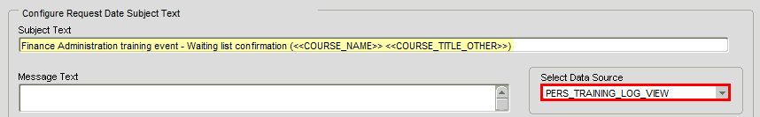

Add your “Subject Text” in the field provided and click “Save”.

- Click “Configure Message” to add the notification message text. Once again, select the data source PERS_TRAINING_LOG_VIEW:
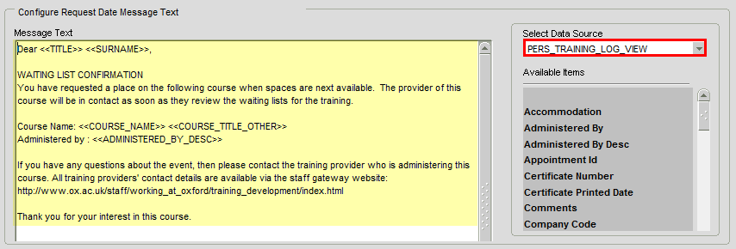

Add your “Message Text” in the field provided and click “Save”.

- Make the event active by ticking the “Active Indicator” flag.
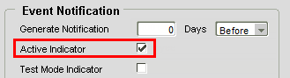

 | Note: Ticking the “Active Indicator” means that any notifications created for this event will be sent by email to the users specified in the “Notification Type” field.  If you want to test event notifications without sending emails, untick the “Active Indicator” and tick the “Test Mode Indicator” instead.

- Click  to save your changes. The event will now appear on the main Event Notifications screen.

Editing an existing event

- Open CoreHR and in the toolbar, go to CoreHR > Event Management > Hr Event Configuration


- Select “Training – Employee Courses” from the drop-down menu. All the available Training event types will now appear on the screen.

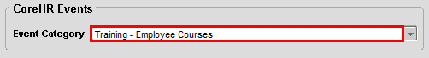
- Select the Event Type which contains the event you want to edit, and click “Edit”.
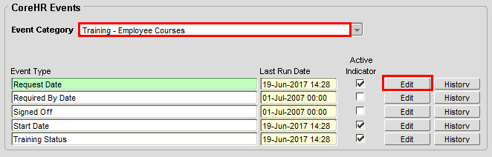
- A pop-up window will open. In the lower half of the window, you can see every event attached to the Event Type you selected. Select the event you wish to edit and click “Edit”.

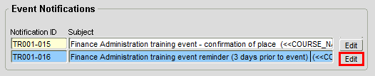

- The event will open in a separate pop-up window. Edit the event settings as required. Remember that to change the subject or message text, you will need to click “Configure Subject” / “Configure Message” to make the text editable.
- Click  to save your changes and exit to the home screen.

Deactivating an existing event

- If you wish to deactivate an event, open CoreHR and in the toolbar, go to CoreHR > Event Management > Hr Event Configuration

- Select “Training – Employee Courses” from the drop-down menu. All the available Training event types will now appear on the screen.

- The Active Indicator flag shows there are three active event types: “Request Date”, “Start Date”, and “Training Status”. Select the event type for which you want to deactivate an event, and click “Edit”.


- A pop-up window will open. In the lower half of the window, you can see every event attached to the event type you selected. To deactivate an existing event, select it and click “Edit”:
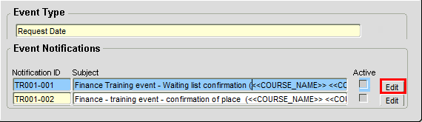

- Untick the “Active Indicator” flag and click “Save Changes”.
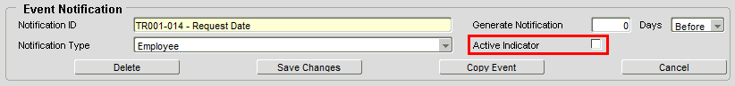

The event will no longer be flagged “active” on the Event Notifications screen.

